Date: 30/06/2026 Web Server and Application Server

Task:
- Install nginx and run nginx on port number 81.
- Deploy a sample index.html file on nginx.
- Install Apache and run Apache on port number 82
- Deploy a sample index.html file on Apache.
- Install Apache tomcat on port number 8082
- Deploy a sample app on webapps
- Create a tomcat.service file for tomcat.
- Configure HA Proxy server

- Nginx Install, Start, Enable and run nginx on port number 81.

$ sudo yum install nginx -y
$ sudo systemctl start nginx
$ sudo systemctl enable nginx
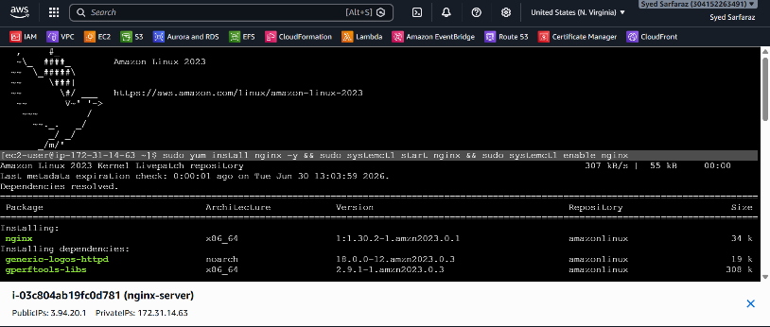
$ sudo systemctl status nginx
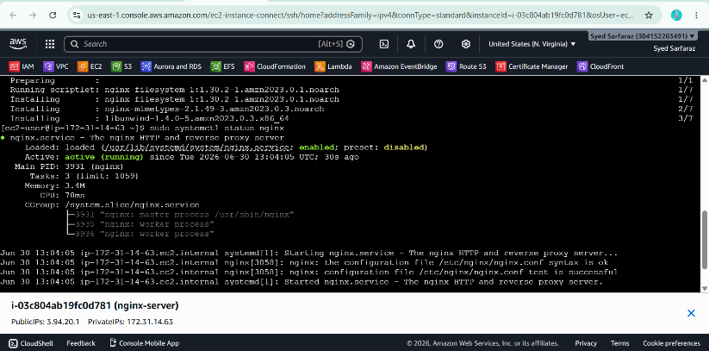

Change Default port form 80 to 81
$ /etc/nginx/nginx.conf
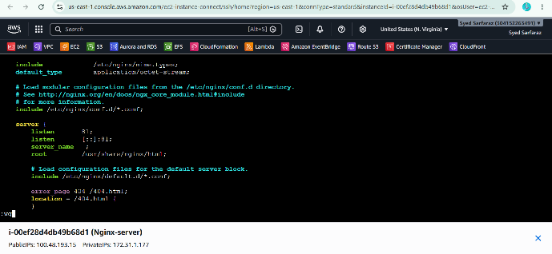
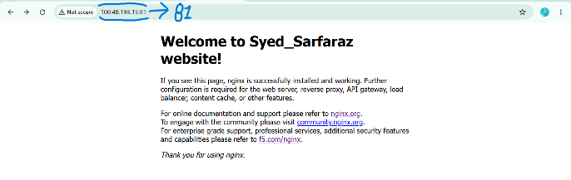

- Deploy a sample index.html file on nginx.
$ vi /usr/share/nginx/html/index.html
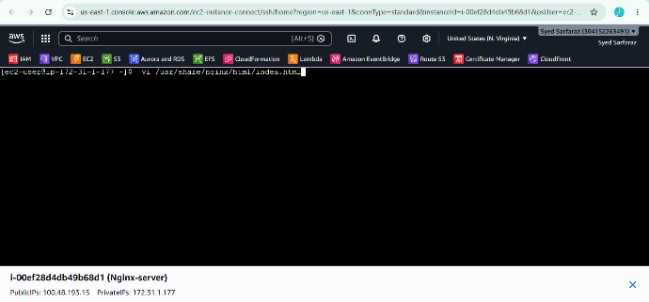
Search on browser; 100.48.193.15:81
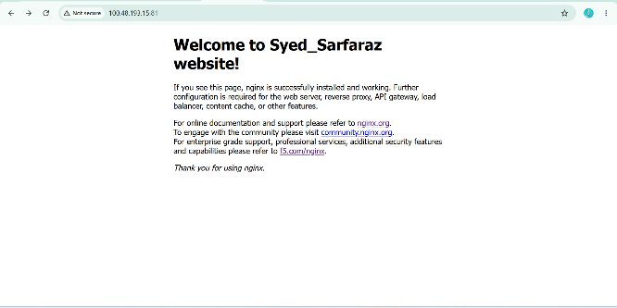

- Install Apache(httpd) and run Apache(httpd) on port number 82
$ sudo yum install httpd -y
$ sudo ststemctl start httpd
$ sudo systemctl enable httpd
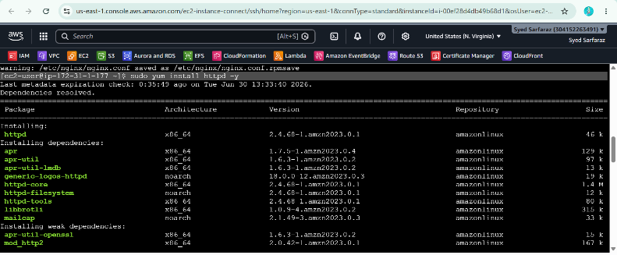
$ sudo systemctl status httpd
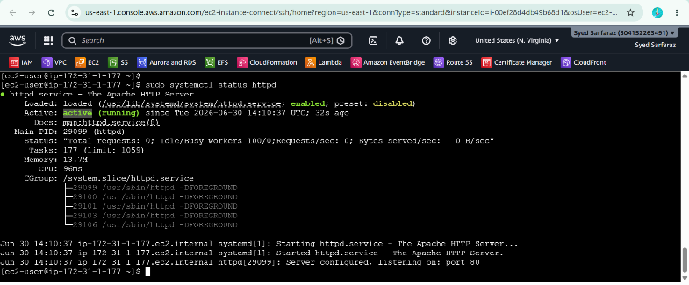

Change Default port form 80 to 82
$ sudo vi /etc/httpd/conf/httpd.conf
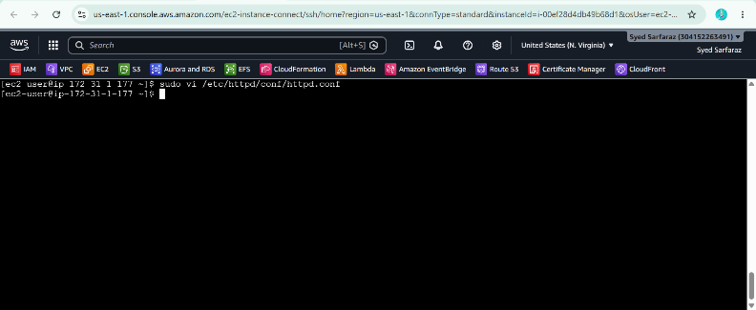
Edit 80 and write 82
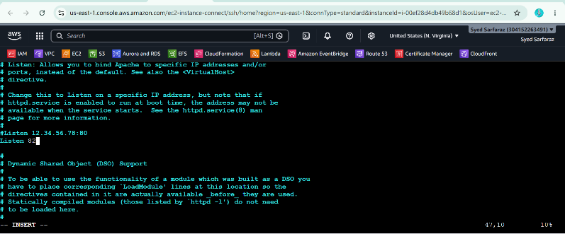
Search on browser; 100.48.193.15:82


- Eploy a sample index.html file on Apache
$ sudo vi /var/www/html/index.html
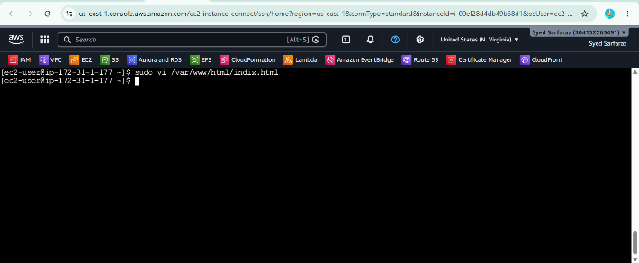
Search on browser; 100.48.193.15:82

- Install Apache tomcat on port number 8082
Install Java Dependency
$ sudo yum update -y
$ sudo yum install java-17-amazon-corretto-devel -y
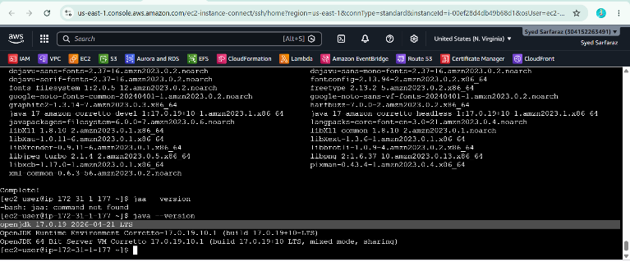

Install Apache Tomcat
$ wget https://dlcdn.apache.org/tomcat/tomcat-10/v10.1.56/bin/apache-tomcat-10.1.56.tar.gz

Extract file
$ tar -xzf apache-tomcat-10.1.56

$ cd apache-tomcat-10.1.56
$ cd bin/
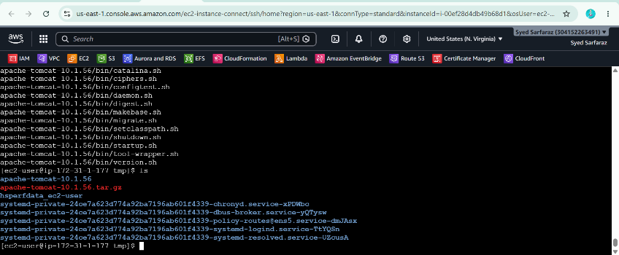

Start the service by using command
$ bash startup.sh
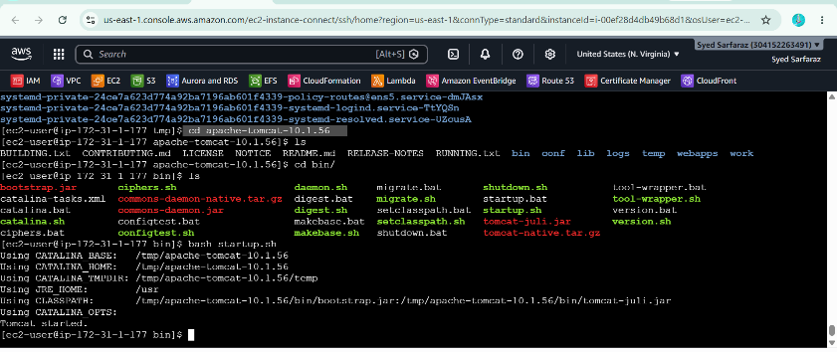

Change Default Port 8080 to 8082
$ cd conf/
$ sudo vi server.xml
And change the port number And

Search on browser; 100.48.193.15:8082
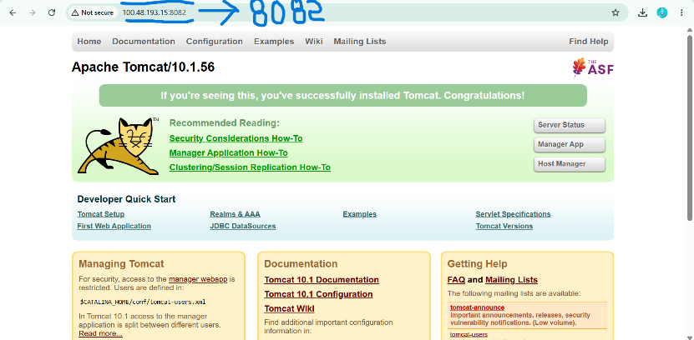

- Deploy a sample app in webapps Directory
$ cd webapps
Download (.war) file and install it by using commands
$ wget <URL>
After Downloading Extract File
$ tar xvf sample.war

Search on browser; 100.48.193.15:8082/sample
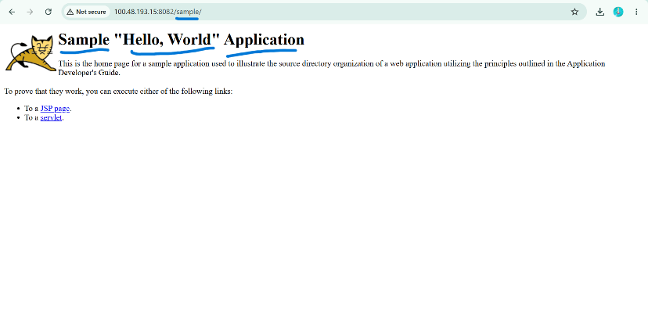

- Create a tomcat.service file for tomcat

- Create the service file
$ sudo vi /etc/systemd/system/tomcat.service
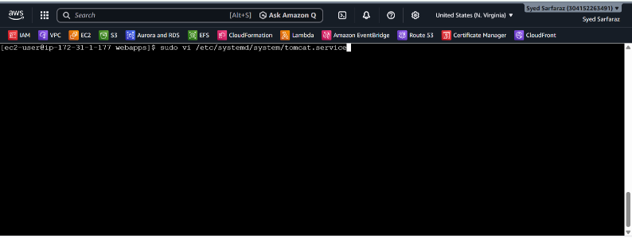

(assuming Tomcat is installed in /tmp/apache-tomcat-10.1.56
[Unit]
Description=Apache Tomcat
After=network.target

[Service]
Type=forking
User=ec2-user
Group=ec2-user

Environment=CATALINA_HOME=/tmp/apache-tomcat-10.1.56

ExecStart=/tmp/apache-tomcat-10.1.56/bin/startup.sh
ExecStop=/tmp/apache-tomcat-10.1.56/bin/shutdown.sh

RemainAfterExit=yes

[Install]
WantedBy=multi-user.target
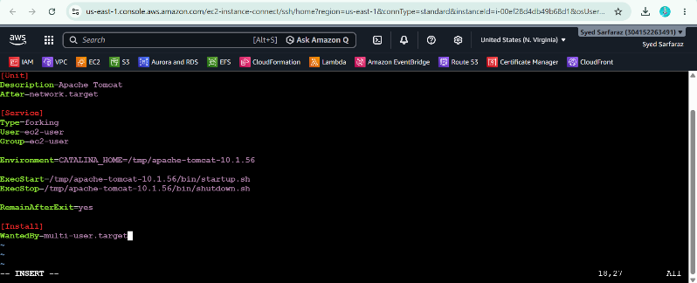

$ sudo systemctl daemon-reload
$ sudo systemctl enable tomcat
$ sudo systemctl start tomcat
$ sudo systemctl status tomcat
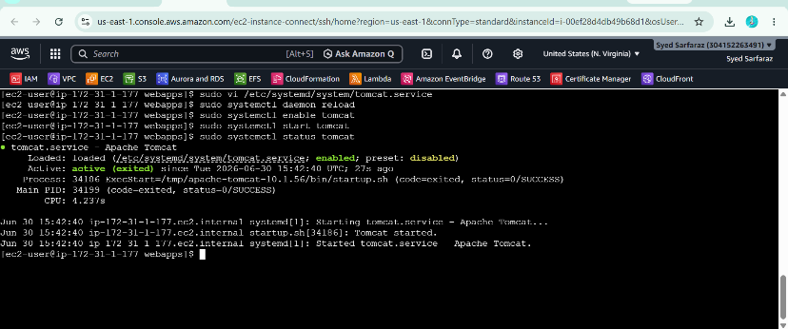

- Configure HA Proxy server

Launch 3 ec2 instances name as Server1, Server-2, HA-Proxy-Server.
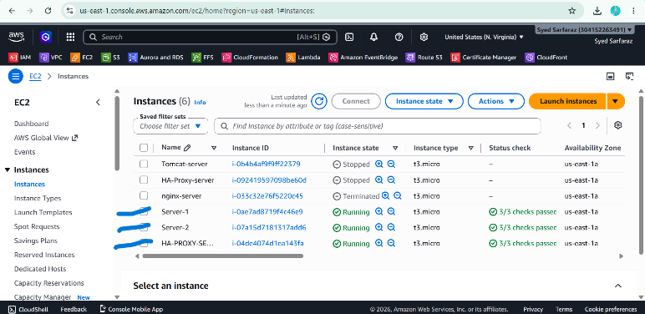

Run following command to Access the Server-1
$ ssh -i "C:\Users\Pc\Downloads\ha-proxy.pem" ec2-user@3.239.175.60
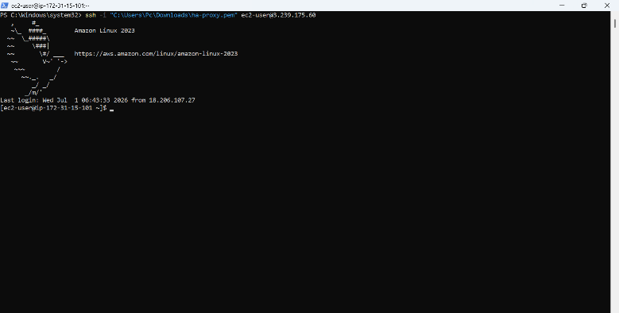
Switch user
$ Sudo -i
$ Sudo update -y
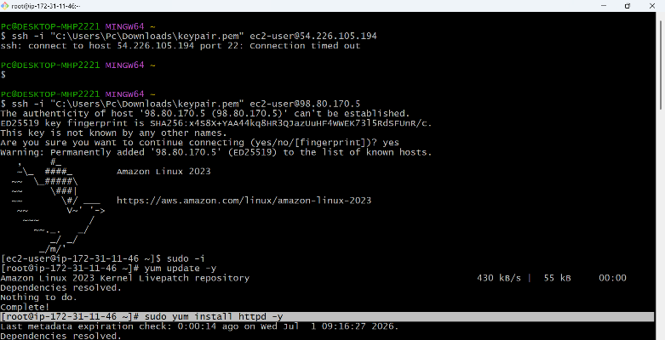
$ sudo yum install httpd -y
$ sudo systemctl start
$ sudo systemctl enable
$ sudo systemctl status
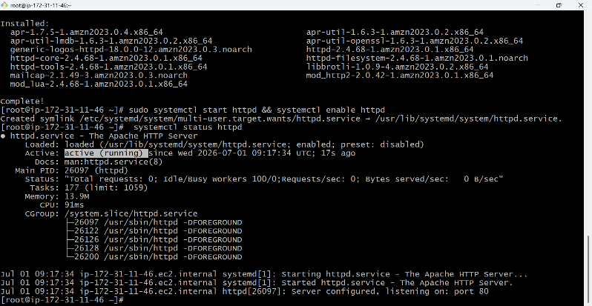
$ Vi /etc/hosts
Add HA-Proxy-Server Pubic IP Address
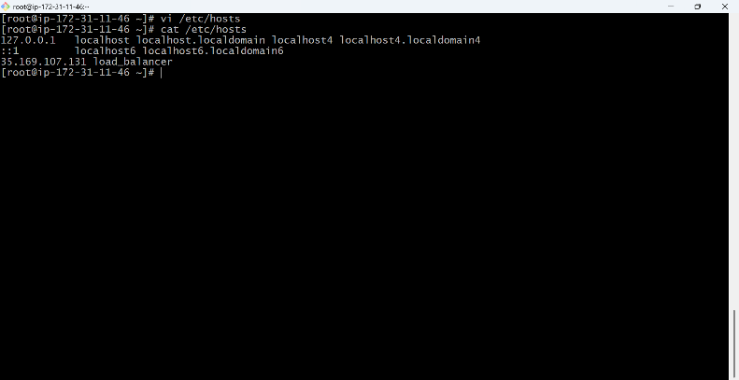
Run below command on Server-1
$ ping load_balancer -c 4
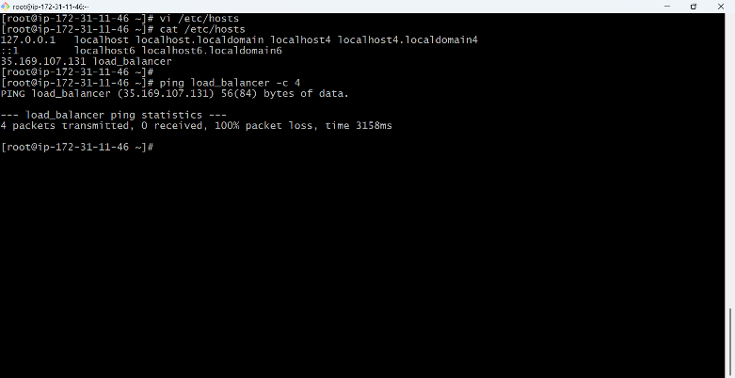
Browse with Server-1 Public IP address:80 it will work


Server-2 Steps:
Run following command to Access Server-2
$ ssh -i "C:\Users\Pc\Downloads\ha-proxy.pem" ec2-user@3.239.175.60
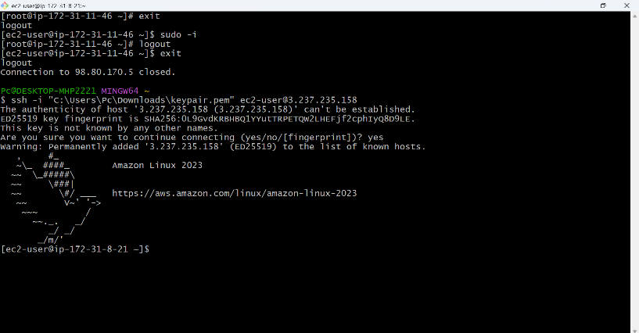
$ yum install nginx -y
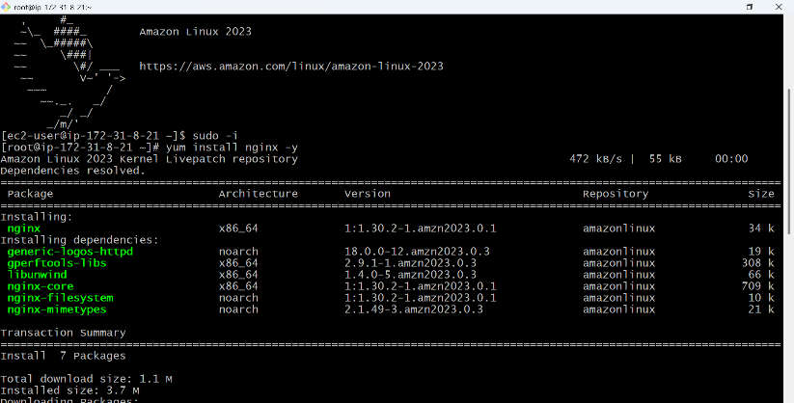
$ systemctl start nginx
$ systemctl status nginx
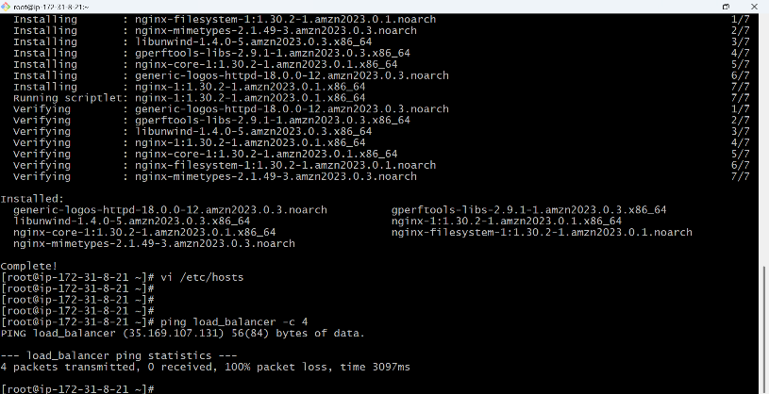
$ vi /etc/hosts
$ Add HA-Proxy-Server Pubic IP Address
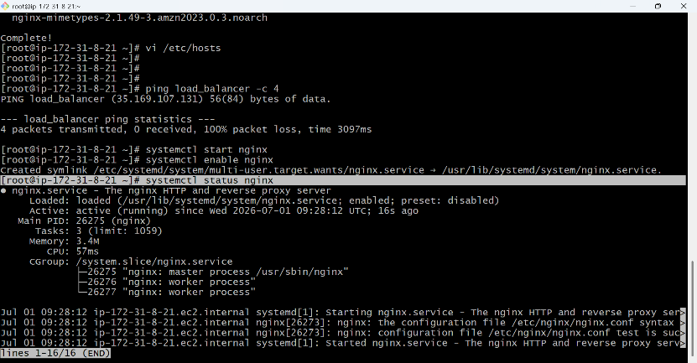
Browse with Server-2 Public IP address:80 it will work
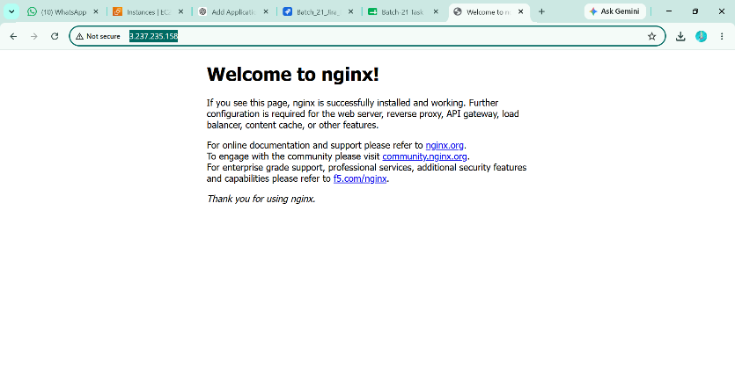
HA-Proxy-Server
yum install haproxy -y
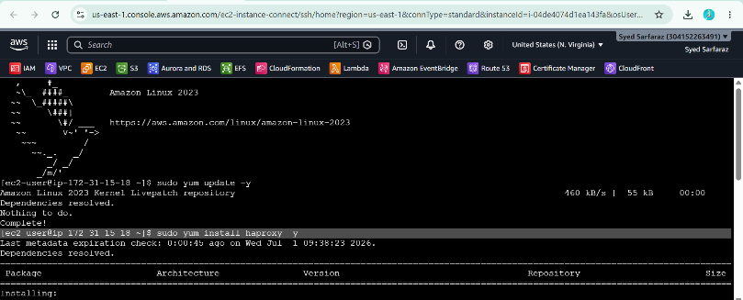
$ systemctl enable haproxy
$ systemctl start haproxy
$ systemctl status haproxy
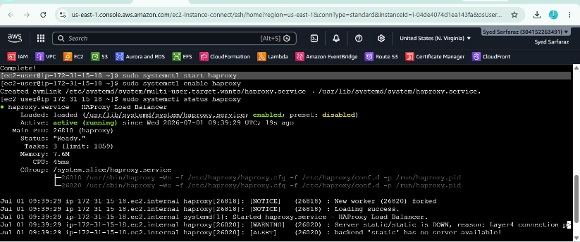

vi /etc/hosts
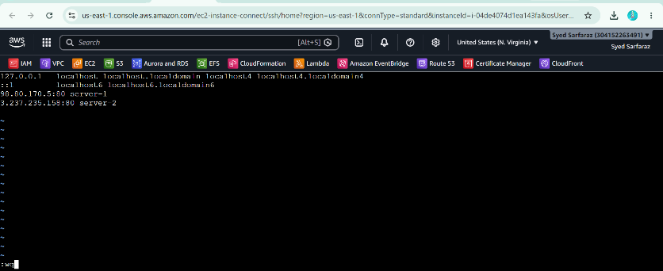
$ vi /etc/haproxy/haproxy.cfg
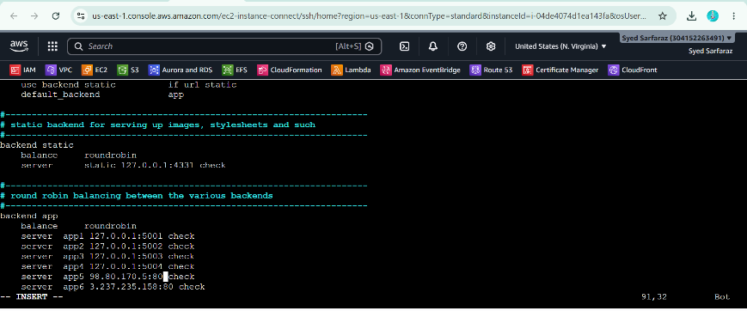

now browse with HA-Proxy-Server PublicIP:80 it will distribute load to Server-1, Server-2

now browse with HA-Proxy-Server PublicIP:80 it will distribute load to Server-1, Server-2
